**A Project report on**

###### Block Chain Based Portal for Farmers

A Dissertation submitted to JNTU Hyderabad in partial fulfillment of the academic requirements for the award of the degree.

#### Bachelor of Technology

##### in

**Computer Science and Engineering**

Submitted by

V Datta Sai (20H51A0525)

K Sreehaas (20H51A0567)

T Himesh Baradwaj (20H51A05A7)

Under the esteemed guidance of Ms. K. Jyothi

(Assistant Professor)



**Department of Computer Science and Engineering**

###### CMR COLLEGE OF ENGINEERING & TECHNOLOGY

(UGC Autonomous)

*Approved by AICTE *Affiliated to JNTUH *NAAC Accredited with A+ Grade

KANDLAKOYA, MEDCHAL ROAD, HYDERABAD - 501401.

###### 2020- 2024

**CMR COLLEGE OF ENGINEERING & TECHNOLOGY**

KANDLAKOYA, MEDCHAL ROAD, HYDERABAD – 501401

**DEPARTMENT OF COMPUTER SCIENCE AND ENGINEERING**



###### CERTIFICATE

This is to certify that the Major Project report entitled **"Block Chain Based Portal for Farmers "** being submitted by V.Datta Sai (20H51A0525), K.Sreehaas (20H51A0567), T.Himesh Baradwaj (20H51A05A7) in partial fulfillment for the award of **Bachelor of Technology in Computer Science and Engineering** is a record of bonafide work carried out his/her under my guidance and supervision.

The results embodies in this project report have not been submitted to any other University or Institute for the award of any Degree.

|  |  |  |
| --- | --- | --- |
| **Dr. S. Kirubakaran**  **Professor** | **Dr. Siva Skandha Sanagala**  **Associate Professor and HOD** |  |
| **Dept. of CSE** | **Dept. of CSE** | **EXTERNAL EXAMINER** |

###### ACKNOWLEDGEMENT

With great pleasure we want to take this opportunity to express our heartfelt gratitude to all the people who helped in making this project a grand success.

We are grateful **to Ms. K.Jyothi , Assistant Professor** , Department of Computer Science & Engineering for his valuable technical suggestions and guidance during the execution of this project work.

We would like to thank**, Dr. S. Siva Skandha,** Head of the Department of Computer Science & Engineering, CMR College of Engineering and Technology, who is the major driving forces to complete our project work successfully.

We are very grateful **to Dr. Ghanta Devadasu**, Dean-Academics, CMR College of Engineering and Technology, for his constant support and motivation in carrying out the project work successfully.

We are highly indebted to **Major Dr. V A Narayana,** Principal, CMR College of Engineering and Technology, for giving permission to carry out this project in a successful and fruitful way.

We would like to thank the Teaching & Non- teaching staff of Department of Dept Name for their co-operation.

We express our sincere thanks to **Shri. Ch. Gopal Reddy**, Secretary& Correspondent, CMR Group of Institutions, and Shri Ch Abhinav Reddy, CEO, CMR Group of Institutions for their continuous care and support.

Finally, we extend thanks to our parents who stood behind us at different stages of this Project. We sincerely acknowledge and thank all those who gave support directly or indirectly in completion of this project work.

V.Datta Sai 20H51A0525

K.Sreehaas 20H51A0567

T.Himesh Baradwaj 20H51A05A7

CHAPTER NO.

**TABLE OF CONTENTS**

TITLE PAGE

**NO.**

LIST OF FIGURES iii

ABSTRACT iv

1. INTRODUCTION 1
   1. Problem Statement 2
   2. Research Objective 3
   3. Project Scope 4
   4. Project Limitations 5
2. BACKGROUND WORK 6
   1. Block Chain Technology in Farmer’s Portal 7
      1. Introduction 7
      2. Merits,Demerits and Challenges 8
      3. Implementation 9
   2. Farmers Agricultural Portal in BlockChain Technology 10
      1. Introduction 10
      2. Merits,Demerits and Challenges 11
      3. Implementation 12
   3. Farmer Portal – A Machine Learning Based Model 13
      1. Introduction 13
      2. Merits,Demerits and Challenges 14
      3. Implementation 15-16
3. PROPOSED SYSTEM 17
   1. Objective of Proposed Model 18

3.2. Technologies Used In Proposed Model 19-21

* 1. Designing 22
     1. UML Diagram 22-24
     2. Sequence Diagram 25-27
     3. Use Case Diagram 27-28

3.4. Stepwise Implementation and Code 29-36

1. RESULTS & DISCUSSIONS 37
   1. Comparison of Existing Solutions 38
   2. Proposed System Analysis 39-41
2. CONCLUSION 42
   1. Conclusion 43

**REFERENCES** 44-45

GITHUB LINK 46

**RESEARCH PAPER AND CERTIFICATE**

|  |  |  |
| --- | --- | --- |
| **FIGURE** | **LIST OF FIGURES**  **TITLE** | **PAGE NO.** |
| **NO.** |  |  |
| 2.1 | Home page of Farmers Agricultural Portal in Blockchain Technology | 12 |
| 2.2 | Additional Features which gives information about crops | 12 |
| 2.3 | Crop Prediction System Using Machine Learning | 15 |
| 2.4 | User Signup Page for Crop Prediction | 16 |
| 3.2.1 | Logos of HTML , CSS , JS | 19 |
| 3.2.2 | Python and Django | 20 |
| 3.3.1 | UML Diagram | 22 |
| 3.3.2 | Sequence Diagram | 25 |
| 3.3.3 | Use Case Diagram | 27 |
| 3.4.1 | XAMPP Control Panel | 29 |
| 3.4.2 | Images reflecting Metamask transactions | 36 |
| 4.1 | Home Page | 39 |
| 4.2 | Admin Side Data | 39 |
| 4.3 | ViewSellers Registered Users | 40 |
| 4.4 | ViewBuyers Registered Users | 40 |
| 4.5 | Admin View All Purchased | 41 |
| 4.6 | Transaction Details | 41 |

ABSTRACT

Blockchain technology utilizes a decentralized network to securely record and confirm transactions, typically associated with cryptocurrencies. Its key features include immutability and transparency, making it suitable for various applications. This paper advocates for integrating blockchain into a farmer's portal to maintain records of crop transactions. By leveraging Python programming language, the proposed solution aims to offer a user-friendly interface for farmers to input details of sellers, buyers, items sold, and transaction values, ensuring the integrity of trade contracts.

The proposed solution presents a practical application of blockchain technology in the agricultural sector, specifically targeting farmers and vendors. By utilizing Python alongside blockchain, it streamlines the process of recording buying and selling information for crops. This integration enhances transparency and security, providing stakeholders with a reliable platform to preserve transaction records and facilitate trade with confidence.

Overall, the integration of blockchain technology with a farmer's portal offers significant benefits by ensuring the immutability and transparency of transaction records. Through Python programming, the solution provides a user-friendly interface, empowering farmers and vendors to securely document and track their transactions, thereby enhancing trust and efficiency in agricultural trade.

# CHAPTER 1

## INTRODUCTION

###### CHAPTER 1 INTRODUCTION

* 1. Problem Statement

The blockchain-based portal addresses challenges in crop demand and sale prices, prioritizing farmers' livelihoods and fair compensation for their produce. It serves as a digital tool for farmers, simplifying the selling process, ensuring fair prices, and recording transactions comprehensively. The project aims to advance towards a decentralized network, offering essential services to empower the next generation and promote agricultural sustainability.

By leveraging blockchain technology[9], the portal addresses issues of crop demand and fair compensation for farmers. It streamlines the selling process and maintains detailed transaction records, enhancing transparency and trust. The project's goal is to promote decentralization, providing vital services to empower future generations and foster sustainability in agriculture.

The blockchain-based portal revolutionizes agricultural transactions[10], prioritizing farmers' welfare and fair compensation. It simplifies the selling process, ensures just prices, and records transactions securely. With a focus on decentralization, the project aims to empower future generations and promote agricultural sustainability.

* 1. Research Objective

The primary objective of this research is to assess the feasibility and potential impact of integrating blockchain technology with farmer's portals in the Indian agricultural sector[3]. Specifically, our research aims to achieve the following:

Evaluate Technological Viability: Determine the technical feasibility of integrating blockchain technology with existing farmer's portals and assess the compatibility of such a system with the Indian agricultural landscape.

Assess Transparency and Trust: Investigate how the use of blockchain technology enhances transparency, security, and trust within agricultural trade, with a focus on how it can benefit both farmers and other stakeholders.

Examine Efficiency Gains: Analyze the potential efficiency gains in agricultural trade processes, including reduced paperwork, faster transactions, and minimized reliance on intermediaries.

Empower Farmers: Assess the extent to which the proposed blockchain-based system empowers farmers by enabling them to secure fair prices for their crops, access financial services, and take control of their trade transactions.

Analyze Market Impact: Explore the broader economic and market impact of implementing blockchain technology, including its potential to transform the agricultural ecosystem in India.

* 1. Project Scope

The project "BLOCKCHAIN BASED PORTAL FOR FARMERS" aims to address the challenges faced by farmers in selling their crops efficiently and securely. By providing an online platform, farmers gain access to a centralized marketplace where they can showcase their produce and engage in e-commerce activities seamlessly. Through the utilization of Blockchain technology, the portal ensures the integrity and security of transactional data, safeguarding against tampering or unauthorized modifications. Additionally, the implementation of Blockchain enhances transparency in the agricultural trade process, enabling farmers to track payments securely and gain insights into market dynamics. This project not only streamlines the selling process for farmers but also fosters trust and accountability within the agricultural community, contributing to the sustainable development of the farming sector.

* 1. Project Limitations

The "BLOCKCHAIN BASED PORTAL FOR FARMERS" project faces several limitations, including potential challenges with internet access and technological literacy among farmers, resistance to adopting new platforms, scalability issues as user numbers grow, regulatory and legal complexities, and resource constraints for development and maintenance. Overcoming these limitations will require addressing user education, technological advancements, stakeholder engagement, regulatory compliance, and securing sufficient financial resources. Despite these challenges, successfully navigating them could lead to substantial benefits for farmers and the agricultural sector overall.

# CHAPTER 2

## BACKGROUND WORK

###### CHAPTER 2 BACKGROUND WORK

* 1. Block Chain Technology in Farmer’s Portal[1]
     1. Introduction

In the realm of agriculture, farmer's portals have emerged as indispensable tools, providing farmers with user-friendly access to essential agricultural information. Blockchain technology operates as a public ledger, addressing critical aspects such as transaction protocols, consensus mechanisms, security, privacy, and authenticity. Cryptography, integral to blockchain functionality, ensures transaction security and immutability through mechanisms like public key encryption and cryptographic hash functions. Efforts to bolster these aspects within blockchain technology are ongoing, with the goal of fostering secure platforms for electronic transactions in agriculture. The presented farmer's portal represents a significant stride in this direction, aiming to facilitate transparent contracts between farmers and customers while ensuring fair pricing for agricultural products. Moreover, it serves as a centralized record-keeping platform for trade transactions, contributing to the sector's efficiency and transparency.

In the contemporary digital landscape, access to timely and relevant information is paramount for informed decision-making. While the advancement of information and communication technology has facilitated access to a vast repository of information on the internet, language barriers remain a significant hurdle. In countries like India, where a considerable portion of the population lacks proficiency in the English language, accessing and understanding online content poses challenges, particularly for farmers. Bridging this gap requires innovative solutions that accommodate linguistic diversity and technical literacy, ensuring that all stakeholders, including farmers, can harness the benefits of digital platforms effectively.

* + 1. Merits, Demerits and Challenges Merits:

**Merits :**

The farmer's portal ensures fair pricing and transparent transactions by employing tamper-proof record-keeping mechanisms. Through centralized management, it streamlines trade processes, providing farmers with a user-friendly platform. Utilizing blockchain ensures robust data security, enhancing trust among stakeholders. Moreover, the portal facilitates collaboration and informed decision-making within the agricultural community. Its features support efficient trade practices and contribute to the overall sustainability of the sector.

Demerits:

The success of the portal depends on farmers' access to technology and infrastructure, which may exacerbate the digital divide. Rural areas, in particular, face challenges due to unreliable internet connectivity. Implementation and maintenance costs pose barriers, especially for smaller farmers with limited resources. Furthermore, ensuring data privacy and security demands careful consideration in system design and operation to mitigate risks effectively. Addressing these challenges is crucial to maximizing the portal's utility and accessibility for all agricultural stakeholders.

Challenges:

To ensure widespread adoption in rural areas, comprehensive efforts are needed to address digital illiteracy and bridge the infrastructure gap. Providing access to essential technology and internet connectivity is crucial to empower farmers in remote regions. Additionally, the portal's interface should be designed to support multiple languages, reflecting the linguistic diversity of India's farming community. Moreover, scalability and performance considerations are paramount to ensure seamless operation, particularly during peak transaction periods. Investing in scalable infrastructure and efficient systems will enable the portal to handle increasing transaction volumes effectively, ensuring uninterrupted service for users across diverse agricultural domains. Ultimately, prioritizing these aspects will contribute to the portal's effectiveness and accessibility, facilitating its widespread adoption and empowering farmers nationwide.

* + 1. Implementation Sellers:

Sellers begin by registering, providing a valid email and mobile number. Upon registration, the admin activates these seller accounts. Once activated, sellers can log in and are granted the ability to add new items, update existing listings, and adjust item prices. This empowers them to expand their market reach and reduces the need for intermediaries in the selling process.

Buyers:

Similar to sellers, buyer users start by registering with valid email and mobile information. Admin approval is necessary for these buyer accounts to become active, allowing users to access the system. Buyers can then browse and purchase products that meet their requirements. They can add products to their shopping cart and remove items as needed. After finalizing their selections and verifying the cart, users can proceed to the checkout process.

Admin:

Administrators have access to the system via their own credentials. They are responsible for activating both seller and buyer accounts. Only activated users can log in to the application. Additionally, the admin user has the capability to oversee all transactions conducted by buyer users. The admin frame provides visibility into all blockchain transactions, complete with details of previous blocks and hash values.

* 1. Farmers Agricultural Portal in Blockchain Technology [2]
     1. Introduction

Agriculture serves as a cornerstone of a country's economic foundation, playing a pivotal role in its Gross Domestic Product (GDP). Throughout history, various agricultural revolutions, such as India's green, yellow, and blue revolutions, have spearheaded advancements in farming practices, significantly influencing the nation's agricultural landscape. These revolutions have not only boosted productivity but also impacted biodiversity, shaping the environment in which agricultural activities take place.

In response to the evolving agricultural landscape, the introduction of a farmer's portal marks a significant step towards modernizing agricultural practices and improving farmers' livelihoods. By providing a platform for farmers to sell their products at better rates, the portal aims to empower agricultural communities. Through this system, farmers gain the ability to update product information, thereby facilitating better pricing strategies and enhancing profit margins, ultimately contributing to the overall economic growth of the agricultural sector.

A key principle underpinning the farmer's portal is the promotion of direct sales between farmers and customers, bypassing intermediaries. This approach ensures that farmers receive the full profit from their sales, while customers benefit from access to fresh and affordable agricultural products. By establishing a direct line of communication between users and farmers, the portal fosters transparency and trust within the agricultural supply chain, thereby promoting fair trade practices and enhancing the economic resilience of farming communities.

By providing farmers with access to weather forecasts and crop planning tools, the portal empowers them to make informed decisions about their farming practices. Additionally, by disseminating information about crops across India, the portal promotes awareness and adoption of modern farming technologies among farmers, thus paving the way for sustainable agricultural practices and ensuring the sector's continued growth and prosperity.

* + 1. Merits, Demerits and Challenges Merits:

Efficiency: Implementation of the max-prior algorithm prioritizes customers with the highest demands, facilitating efficient allocation of products to meet significant needs promptly.

Reduction in Stock Loss: Allocating products based on demand minimizes stock wastage for farmers, optimizing sales and reducing losses.

Improved Customer Satisfaction: Prioritizing high-demand customers ensures prompt product delivery, enhancing overall satisfaction with the service provided.

Demerits:

Limited Product Availability: The algorithm may result in situations where some customers receive products while others encounter "out of stock" messages, potentially leaving certain customers unsatisfied.

Potential Overstock: Assigning products to high-demand customers and then switching to the next farmer growing the same crop could lead to overstock for some farmers and understock for others, causing imbalances in the supply chain.

Complexity: Implementing a max-prior algorithm can be intricate, requiring a robust and up-to-date system to manage demand, stock, and customer requirements accurately. This complexity may pose challenges in system maintenance and operation.

Challenges:

Implementing the max-prior algorithm faces several challenges. Balancing product availability while prioritizing high-demand customers is crucial to prevent dissatisfaction. Efficient inventory management is necessary to avoid overstocking and understocking, requiring real-time monitoring and adjustment. The complexity of the algorithm demands a robust system and technical expertise for effective implementation and maintenance. Additionally, ensuring customer satisfaction amidst limited product availability presents a significant challenge that needs careful consideration and management.

* + 1. Implementation

Proposed System Overview: The proposed system is a web application developed using CSS, JavaScript, and SQLite3. It facilitates direct selling of farm products from farmers to customers without intermediary involvement. The development methodology involves breaking down the system into smaller components, allowing for incremental progress and iterative improvements.

User Registration and Interaction: The website offers registration and login options for farmers, customers, and wholesalers. Farmers can add products and access live weather information. Customers and wholesalers can communicate with farmers for information and queries regarding available farm products.

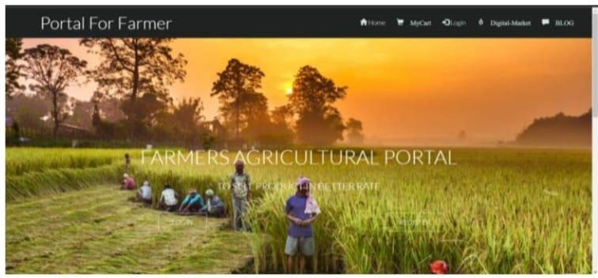

Fig No. 2.1: Home page of Farmers Agricultural Portal BlockChain Technology [7]

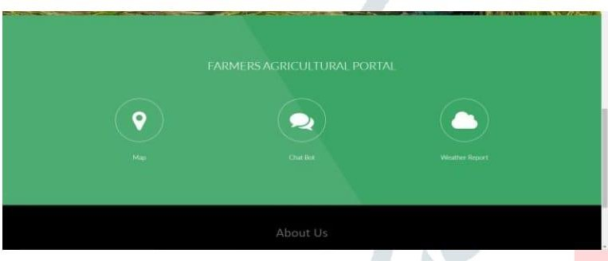Technology Utilized: Information technology plays a crucial role, providing an online platform for farmers to sell products directly to consumers, bypassing intermediaries. Features include a "CHAT BOT" for user communication and a weather map to aid farmers in making informed crop choices based on weather conditions.

Fig No. 2.2 : Additional Features which gives information about crops [7]

* 1. Farmer Portal – A Machine Learning Based Model [4]
     1. Introduction

Agriculture stands as a unique sector within the economy, heavily influenced by climate conditions. The success of agricultural production and its economic impact hinge on how well climate conditions align with the optimal requirements of crop growth. Maximizing crop yields effectively requires exploiting these conditions to their fullest potential. Moreover, effective management of adverse climate effects, including moisture levels, temperature, wind, radiation, and biotic stress, is crucial for mitigating their impact on crop growth and development.

Additionally, managing crops to withstand severe weather conditions is a critical aspect of agricultural practice. Despite technological advancements, agriculture remains the backbone of the Indian economy. Even today, the country's economic foundation heavily relies on agriculture, particularly in rural areas. Agriculture significantly contributes to the Gross Domestic Product (GDP), accounting for around 16% of the total and employing approximately 52% of the Indian population. The sector's growth is vital not only for national self-sufficiency but also for earning valuable foreign exchange.

In this context, the introduction of a user-friendly portal for farmers holds significant promise. Such a portal can provide valuable crop recommendations based on factors like local conditions and potential profitability. The Farm Portal aims to offer farmers updates on agriculture-related news and real-time climate information, enabling them to make informed decisions regarding crop selection. These services are accessible through a compressed web format that doesn't demand excessive storage space. This portal has the potential to revolutionize the way farmers access vital information and improve agricultural practices in India.

* + 1. Merits, Demerits and Challenges Merits:
       - Agricultural Empowerment: The proposed portal aims to empower Indian farmers with valuable insights regarding crop selection, market prices, and weather conditions, enabling them to make informed decisions and potentially increase productivity and profits.
       - Machine Learning Integration: The use of machine learning algorithms for crop yield and price prediction can provide farmers with accurate and data-driven recommendations, enhancing their decision-making processes.
       - Comprehensive Solution: By offering a single platform catering to farmers' diverse needs, including crop selection, market prices, soil type, government schemes, and weather information, the portal simplifies and streamlines access to crucial agricultural information.
       - User-Friendly: Designed to be user-friendly, the portal ensures that farmers can easily access and understand the provided information. It includes features such as weather updates and crop recommendations based on location.

Demerits :

* + - * Data Accuracy: The effectiveness of machine learning algorithms heavily depends on the quality and accuracy of the data used for training. Inaccurate or incomplete data can result in unreliable recommendations.
      * Digital Literacy: Some farmers may have limited digital literacy, making it challenging for them to use the portal effectively. Training and support may be required to ensure that all farmers can benefit from the platform.
      * Storage and Bandwidth: While the results are mentioned to be in a compressed web format, the portal's potential success will depend on its ability to manage and serve data efficiently to a potentially large user base, which may pose storage and bandwidth challenges.
    1. **Implementation**

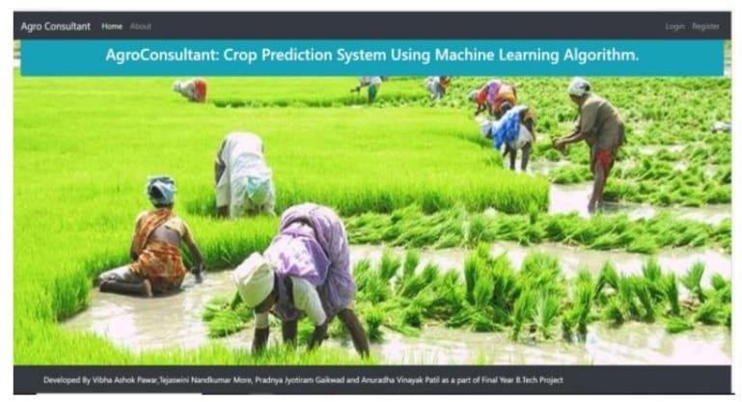For the front-end of the platform, the development focuses on creating a responsive and user-friendly web interface. Two popular frameworks, React or Angular, are considered for building this interface. The user experience and design are vital components, and tools like Adobe XD or Figma are used to craft an intuitive and aesthetically pleasing design. Geolocation services are integrated into the front-end using JavaScript libraries like Leaflet to provide mapping and location-based features.

Fig No. 2.3 :Crop Prediction System Using Machine Learning [6]

On the server side, either Python or Node.js is selected as the programming language for back-end development. To enhance the platform's functionality, machine learning is employed, utilizing Python libraries such as scikit-learn or TensorFlow to develop crop recommendation algorithms. User data, including profiles, preferences, and feedback, is stored in a MongoDB database. Real-time weather updates are made possible through integration with a weather data provider, such as OpenWeatherMap.

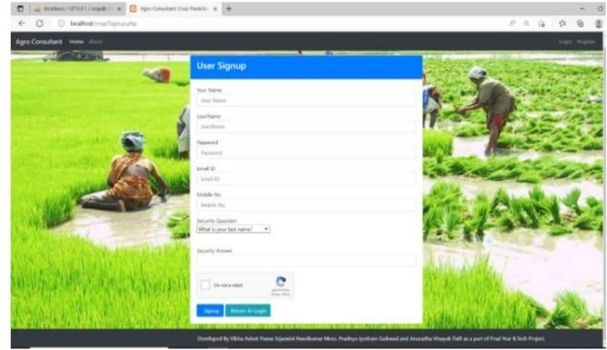

Fig No.2.4 : User Signup Page for Crop Prediction [6]

Additionally, a content management system (CMS) like WordPress is used to manage and update agricultural news and information, ensuring that users have access to current and relevant content. The platform incorporates push notification services to keep users informed and engaged. These notifications are implemented using Firebase Cloud Messaging for Android devices and the Apple Push Notification Service (APNs) for iOS devices.

Security is a paramount concern, and the platform ensures robust measures. User authentication is implemented using JSON Web Tokens (JWT), offering secure access to the system. Additionally, data encryption and secure data transmission are enforced by incorporating HTTPS for user data protection and privacy.

# CHAPTER 3

## PROPOSED SYSTEM

* 1. Objective of Proposed Model

The proposed Farmer’s portal serves as a unified platform facilitating e-commerce transactions for crops. Customizable to individual needs, it offers a singular access point, streamlining the entire process with a single login for approved users. Users, whether buyers or sellers, including farmers or their representatives, engage with the interface through registration and login procedures. Upon successful authentication, users gain access to the portal, enabling them to initiate transactions efficiently. Notably, all transactions are visible to participants within the network, leveraging blockchain technology's[9] transparency and security features.

In addition to facilitating buyer-seller transactions, the portal also supports wallet-to- wallet transactions, further enhancing its functionality. With this feature, users can seamlessly transfer funds between their digital wallets within the platform. This capability not only simplifies financial transactions but also adds a layer of convenience for users, enabling them to manage their finances directly within the portal's ecosystem. Moreover, leveraging blockchain's peer-to-peer transaction model and encryption techniques, wallet-to-wallet transactions ensure secure and tamper-proof exchanges of digital assets.

The integration of wallet-to-wallet transactions[10] augments the Farmer’s portal's utility, providing users with a comprehensive platform for all their agricultural commerce needs. By incorporating this feature alongside its existing functionalities, the portal enhances user experience, fosters financial inclusivity, and reinforces its position as a secure and efficient platform for agricultural transactions. As a result, farmers, buyers, and other stakeholders can leverage the portal's capabilities to conduct transactions seamlessly while enjoying the benefits of blockchain technology's security and transparency.

* 1. Technologies Used In Proposed Model

**Operating System**

The software requirement stipulates compatibility with Windows 8 or above, ensuring widespread accessibility across a broad range of devices. Windows operating systems are renowned for their user-friendly interfaces and widespread adoption among both personal and business users. By targeting Windows 8 and above, the Farmer’s portal can cater to a large user base, encompassing desktop computers, laptops, and tablets running the specified operating systems.

Front-end Technologies

HTML, CSS, and JavaScript serve as the cornerstone of the Farmer’s portal's front- end development. HTML (Hypertext Markup Language) provides the structural foundation for web pages, defining the layout and organization of content. CSS (Cascading Style Sheets) enhances the presentation of HTML elements, allowing for customization of colors, fonts, and layouts to create visually appealing interfaces. JavaScript adds interactivity and dynamic behavior to web pages, enabling features such as form validation, animations, and asynchronous data fetching.

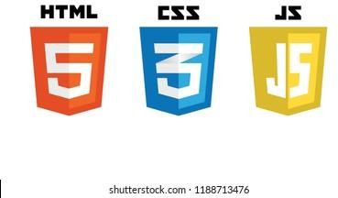

Fig No 3.2.1 : Logos of HTML, CSS, JS .

Python Programming Language

Python is selected as the primary programming language for the Farmer’s portal due to its simplicity, readability, and extensive ecosystem of libraries and frameworks. Python's syntax emphasizes readability and productivity, making it well-suited for rapid application development. Its versatility allows developers to tackle a wide range of tasks, from web development to data analysis and machine learning. Python's popularity in the web development community ensures ample resources and support for building robust and scalable web applications like the Farmer’s portal.

Django Framework

The Django framework is utilized to streamline the development process and maintain consistency in code structure and organization. Django is a high-level Python web framework that encourages rapid development and clean, pragmatic design. It provides a comprehensive set of tools and features, including an object-relational mapping (ORM) system for database interaction, built-in security mechanisms, and a powerful templating engine. Django's "batteries-included" approach simplifies common web development tasks, allowing developers to focus on building features and functionality rather than boilerplate.



Fig No. 3.2.2 : Python and Django

SQLite Database

SQLite serves as the database management system for the Farmer’s portal, offering a lightweight and efficient solution for storing and retrieving data. SQLite is a self- contained, serverless, zero-configuration SQL database engine that is embedded directly into the application. It requires minimal setup and administration, making it well-suited for

small to medium-sized web applications like the Farmer’s portal. Despite its lightweight nature, SQLite supports most standard SQL features and is capable of handling typical web application workloads with ease.

Security and Integration Tools

While specific security and integration tools are not mentioned, the Farmer’s portal is likely to incorporate a range of industry-standard practices and technologies to ensure data protection and seamless operation. Security measures may include encryption of sensitive data, robust authentication and authorization mechanisms, and regular security audits and updates. Integration tools may be used to connect the portal with external services or APIs for functionalities such as real-time weather updates, payment processing, or social media integration. By employing these tools and practices, the Farmer’s portal can offer a secure, reliable, and feature-rich platform for agricultural transactions.

* 1. DESIGNING
     1. **UML Diagram**

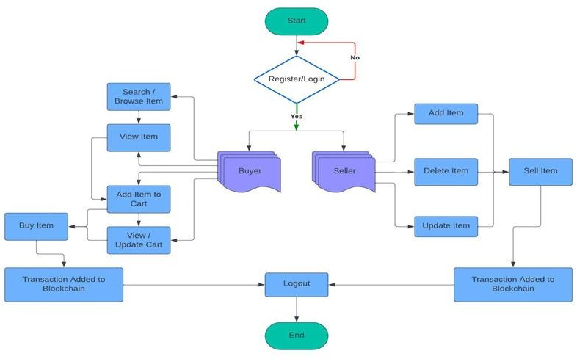

Fig No. 3.3.1 UML diagram

In the era of information and communication technology, a farmer's portal has always been helpful for farmers in many ways, providing ease of use and convenience of information to the farmers. Using blockchain technology in the field can make available decentralized computation and information sharing platform that enables multiple authoritative domains, which do not trust each other, to cooperate, coordinate and collaborate in a rational decision-making process, a reliable information recording system can be made that can contribute to the development in the agriculture sector. Since blockchain works like a public ledger, so it can be utilized to ensure many different aspects:

**Protocols for Commitment:** Ensure that every valid transaction from the clients are committed and included in the blockchain within a finite time.

**Consensus:** Ensure that the local copies are consistent and updated.

**Security:** The data needs to be tamper-proof. Note that the client may act maliciously or can be compromised.

**Privacy and Authenticity:** The data or transactions belong to various clients; privacy and authenticity need to be ensured.

Cryptography is a crucial part of how blockchain technology works. Public key encryption is like the foundation of blockchain wallets and transactions. Cryptographic hash functions give the important quality of immutability, ensuring that data can't be changed. Merkle trees help organize transactions efficiently and make blockchain work better. All these things combined make blockchain secure and efficient.

Ensuring the above aspects numerous work has been carried out in the field of blockchain. The presented portal is a contribution over them. It can help to maintain a secure platform for farmers, where they can trade with the customers electronically. The main objective of this study is to record the secure transactions between a seller and a buyer that ensures a contract between the two. This can help farmers to get a legitimate price for their commodity. The system also facilitates a single place to record the whole trade transaction.

The outlined scenario presents a sophisticated system catering to the needs of both buyers and sellers, featuring distinct functionalities such as user registration, login mechanisms, and a plethora of actions tailored to each user role. To offer a thorough depiction of this system, a UML (Unified Modeling Language) diagram approach is warranted, commencing with a use case diagram and extending to class and sequence diagrams for a more detailed portrayal.

Beginning with the use case diagram, it serves as a visual representation of the interactions between actors (users) and the system, delineating the spectrum of functionalities accessible to each actor. In this scenario, the primary actors identified are Buyers and Sellers. Buyers can engage in various functions including registration, login, item search, item viewing, cart management, and blockchain-based payment initiation. On the other hand, Sellers are empowered with capabilities such as item management, selling processes, and monitoring sold items. Additionally, both user roles share the functionality of logging out, which terminates their current sessions.

Transitioning to the class diagram, it provides a structural blueprint of the system, showcasing the classes, attributes, and methods integral to its architecture. The User class serves as the foundation, encompassing attributes like username and password, along with methods for registration, login, and logout. Extending from the User class, Buyer and Seller classes incorporate role-specific attributes such as cart and inventory, accompanied by methods tailored to their respective functionalities.

Furthermore, the sequence diagram offers a dynamic narrative, depicting the chronological flow of interactions between system objects for specific scenarios. For instance, the sequence of events for a buyer initiating a purchase journey involves sequential steps such as logging in, searching for items, managing the cart, and executing blockchain- based payments. Similar sequences can be illustrated for seller actions such as item management and selling processes.

In essence, these UML diagrams collaboratively provide a holistic visualization of the system's functionalities, interactions, and structure. By leveraging visual modeling techniques, stakeholders can gain a deeper understanding of the system's intricacies, thereby facilitating effective design, development, and refinement processes.

* + 1. Sequence Diagram

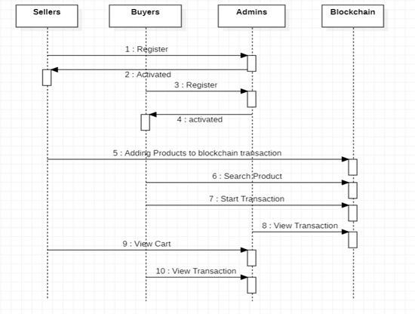

Fig No.3.3.2 : Sequence Diagram

Sellers Registration and Activation :

Sellers Registration: Sellers, who are farmers or agricultural producers, initiate the process by registering on the platform. This registration involves providing necessary information such as contact details, farm location, and types of products they intend to sell.

Buyers' Request: Potential buyers interested in purchasing agricultural products send a registration request to Sellers. This indicates their interest in accessing the platform and engaging in transactions.

Admin Confirmation: Upon receiving the registration request from Sellers, Admins validate the information provided and approve the registration. They then send a confirmation message called "Registered" to the Sellers, acknowledging their successful registration.

Seller Activation: After being registered, Sellers' accounts need to be activated to start listing their products on the platform. Admins verify the authenticity of the Sellers and activate their accounts. Once activated, Admins send a message called "Activated" to the respective Sellers, indicating that they can now start using the platform to sell their products.

Adding Products to Blockchain:

Product Listing: Sellers, upon activation, can start listing their agricultural products on the platform. This involves providing details such as product name, quantity, price, and any other relevant information.

Blockchain Transaction: To ensure transparency and security in the transaction process, Sellers initiate a transaction by sending a message titled "Adding products to blockchain transaction" to the Blockchain. This action records the details of the product listing securely on the Blockchain, making it immutable and transparent.

Verification and Consensus: The Blockchain verifies the transaction and achieves consensus among the network participants to ensure the integrity of the added product information.

Admin Monitoring:

Platform Oversight: Admins play a crucial role in monitoring the platform for any updates, issues, or irregularities. Sellers send a message titled "View Cart" to Admins, allowing them to access and monitor the products listed on the platform. Admins can review the listed products, check for compliance with platform policies, and intervene if necessary to maintain the platform's integrity and quality standards.

Buyer Interaction:

Product Inquiry: Buyers browse through the platform and view the available agricultural products listed by Sellers. When a Buyer wants to make a purchase or inquire about a specific product, they send a message titled "View Transaction" to Admins.

Transaction Facilitation: Admins receive the inquiry from the Buyer and facilitate the transaction process. They provide the Buyer with the necessary information about the product, including its details, availability, and pricing. Additionally, Admins assist in coordinating the transaction between the Buyer and the Seller, ensuring a seamless and

secure exchange.

In essence, the sequence diagram illustrates a comprehensive process flow within the Blockchain-based portal for farmers, encompassing Seller registration, product listing, platform monitoring by Admins, and Buyer interaction. This structured approach ensures transparency, security, and efficiency in agricultural transactions, benefiting both Sellers and Buyers on the platform.

* + 1. Use Case Diagram

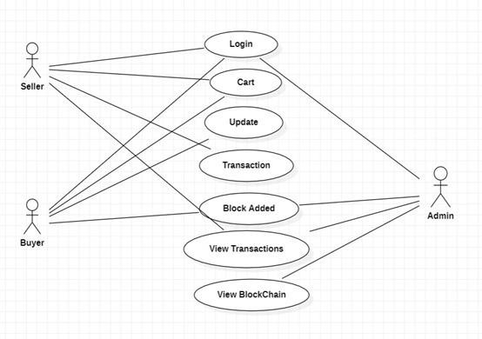

Fig No.3.3.3 :Use Case diagram

The interactions within the Blockchain-based portal for Farmers involve distinct functionalities tailored to Sellers, Buyers, and Admins, each contributing to the platform's overall efficiency and transparency.

Starting with Seller interactions, they initiate the login process by providing their credentials, gaining access to their dashboard and platform features upon successful authentication. Subsequently, Sellers utilize the cart feature to manage their listed products, enabling them to add, remove, or modify items effectively. Transactions are a pivotal aspect of Seller interactions, involving processes such as order confirmation, invoice generation, and transaction status updates. Additionally, Sellers can view transaction details, tracking ongoing and completed transactions to manage their sales activities efficiently.

On the Buyer side, the login process grants access to platform features, allowing them to browse and select agricultural products. Buyers leverage the cart feature to organize their shopping lists and proceed to checkout seamlessly. Moreover, they utilize the update feature to maintain accurate account information and preferences, ensuring a personalized experience. Notably, Buyers receive notifications about new blocks added to the Blockchain, staying informed about the latest platform activities.

Admin interactions are pivotal for overseeing platform operations and ensuring integrity. Admins log in to access administrative features, monitoring the addition of new blocks to the Blockchain ledger to maintain data accuracy. They also have access to transaction details, enabling them to track order statuses and resolve disputes efficiently. Furthermore, Admins can view the entire Blockchain ledger, analyzing transaction records for security and immutability.

In summary, each actor's interactions within the platform contribute to its functionality and efficiency. Sellers manage product listings and transactions, Buyers engage in seamless purchasing experiences, and Admins oversee operations and ensure data integrity. These interactions collectively facilitate transparent and efficient management of agricultural products and transactions within the platform ecosystem.

3.4. Stepwise Implementation and Code

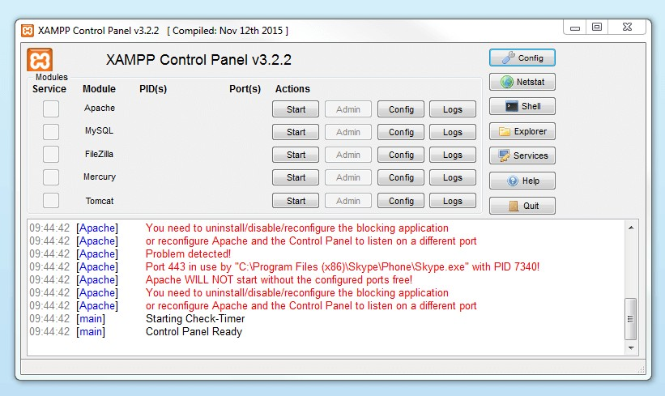To begin the process of running a Django web application locally, the first step is to install XAMPP, a cross-platform web server solution package that includes Apache, MySQL, and PHP. Once XAMPP is installed, you need to start both the Apache and MySQL services from the XAMPP control panel. This allows your computer to serve web pages and access the database required for your Django application.

Fig No.3.4.1 : XAMPP Control Panel

After starting XAMPP services, navigate to the directory containing your Django project's codebase. Within this directory, locate the `manage.py` file, which serves as the entry point for managing your Django project. Open a command prompt or terminal window in this directory.

Next, run the command `python manage.py runserver` in the command prompt. This command starts the Django development server, which hosts your Django application locally. Upon successful execution, the terminal will display a URL, typically

`http://127.0.0.1:8000/`, where your Django application is accessible.

Finally, open a web browser and enter the URL provided by the Django development server. This will load your Django website in the browser, allowing you to interact with it and test its functionality. By following these steps, you can seamlessly set up and run your Django web application locally for development and testing purposes.

Implementation of Code:

{% extends 'buyers/buyerbase.html' %}

{% load static %}

{% block contents %}

<!-- Transaction section for buyers -->

<section class="ftco-section ftco-cart">

<div class="container">

<div class="row">

<div class="col-md-12 ftco-animate">

<!-- Heading showing logged-in buyer ID -->

<h2>Buyer Transaction Initiate <span class="btn btn-info"> {{request.session.loginid}}</span></h2>

<!-- Transaction form -->

<form class="text-left clearfix mt-30"

action="{% url 'StartBlockChainTransaction' %}" method="POST">

{% csrf_token %}

<!-- Input for sender's name, populated from the backend, read-only -->

<div class="form-group">

<label>Sender Name </label>

<input type="text" class="form-control" name="buyername" value="{{buyername}}" readonly>

</div>

<!-- Input for sender's account ID, will be filled by MetaMask interaction -->

<div class="form-group">

<label>Sender Account Id </label>

<input type="text" class="form-control" name="s_accountId" readonly>

</div>

<!-- Input for recipient's account ID, populated from the backend, read-only -->

<div class="form-group">

<label>Recipient Account Id</label>

<input type="email" id="r_account_id" class="form-control" name="recipientnmae" value="{{bank}}" readonly>

</div>

<!-- Input for payable amount, populated from the backend, read-only -->

<div class="form-group">

<label>Payable Amount</label>

<input type="text" id="amount" class="form-control" name="totalamount" value="{{totalPrice}}" readonly>

</div>

<!-- Hidden submit button for the form -->

<input type="button" value="Start Transaction" onclick="sendTransaction()" class="btn btn-success text-center p-2 ml-2">

<input type="button" value="Login to MetaMask" onclick="connectToMetaMask()" class="btn btn-success text-center p-2 mr-2">

<button type="submit" id="hiddenSubmit"

class="btn btn-success text-center" style="display: none;"></button>

</form>

<!-- Displaying messages, if any -->

<center>

{% if messages %}

{% for message in messages %}

<font color='YELLOW'>{{ message }}</font>

{% endfor %}

{% endif %}

</center>

</div>

</div>

</div>

</section>

<script>

// Fetch the current price of 1 ETH in INR using the CoinGecko API async function fetchETHPriceInINR() {

const url

= "https://api.coingecko.com/api/v3/simple/price?ids=ethereum& vs_currencies=inr";

try {

const response = await fetch(url); const data = await response.json(); return data.ethereum.inr;

} catch (error) {

console.error("Error fetching ETH price:", error); return null;

}

}

// Convert a given amount from INR to ETH

async function convertINRToETH(amountInINR) { const ethPriceInINR = await fetchETHPriceInINR(); if (ethPriceInINR !== null) {

const amountInETH = amountInINR / ethPriceInINR; console.log(${amountInINR} INR is approximately

${amountInETH.toFixed(6)} ETH); return amountInETH.toFixed(6);

} else {

console.log("Unable to fetch ETH price for conversion.");

}

}

// Connect to the MetaMask wallet async function connectToMetaMask() { if (window.ethereum) {

try {

const accounts = await window.ethereum.request(

{ method: 'eth_requestAccounts' }); const account = accounts[0];

console.log('Connected account:', account); document.getElementsByName('s_accountId')[0].value = account;

} catch (error) {

console.error('User denied account access');

}

} else {

console.log('MetaMask is not installed');

}

}

// Send a transaction using MetaMask async function sendTransaction() {

if (!window.ethereum) { console.log('MetaMask is not installed'); return;

}

const r_account_id = document.getElementById('r_account_id').value; const amountInInr = document.getElementById('amount').value;

const amountInEther = await convertINRToETH(amountInInr); console.log(amountInEther);

try {

const accounts = await window.ethereum.request(

{ method: 'eth_requestAccounts' }); const from = accounts[0]; console.log(from);

document.getElementsByName('s_accountId')[0].value = from;

// Define and send the transaction const transactionParameters = { to: r_account_id,

from: from,

value: Number(amountInEther * 1e18).toString(16), gasPrice: '0x09184e72a000',

gas: '0x2710', data: '0x0'

};

const txHash = await window.ethereum.request({ method: 'eth_sendTransaction',

params: [transactionParameters],

});

console.log('Transaction hash:', txHash);

} catch (error) {

console.error('Failed to send transaction:', error);

}

}

</script>

{% endblock %}

Transcation Handler :

// SPDX-License-Identifier: MIT pragma solidity ^0.8.0;

contract TransactionHandler {

// Event to emit when ETH is received

event Received(address sender, uint amount);

// Structure to hold transaction details struct Transaction {

address sender;

uint amount;

}

// Array to store transactions Transaction[] public transactions;

// Function to receive ETH and store transaction details receive() external payable {

emit Received(msg.sender, msg.value); transactions.push(Transaction(msg.sender, msg.value));

}

// Function to get the total number of transactions

function getTotalTransactions() public view returns (uint) { return transactions.length;

}

// Function to get transaction details by index

function getTransaction(uint index) public view returns (address, uint) { require(index < transactions.length, "Index out of bounds"); Transaction memory txn = transactions[index];

return (txn.sender, txn.amount);

}

}

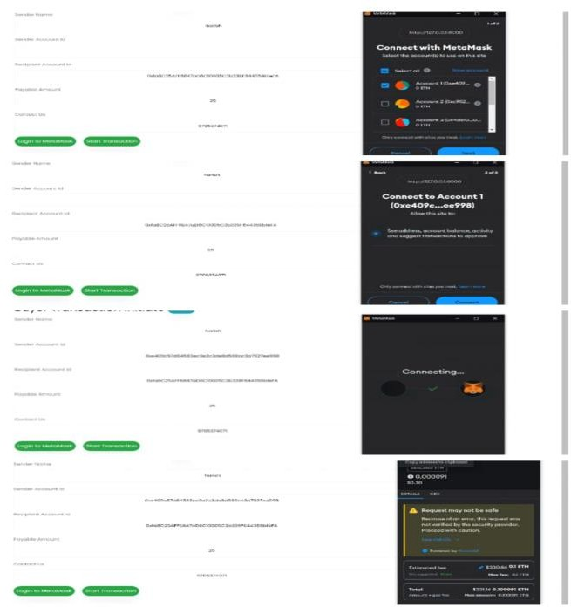

Fig No. 3.4.2 : Images reflecting metamask transactions

# CHAPTER 4

## RESULTS AND DISCUSSION

###### CHAPTER 4 RESULTS AND DISCUSSION

* 1. Comparison of Existing Solutions

In the existing system, farmers, as well as agriculture, are the foundation of life. Numerous works have been done towards the enhancement of agriculture by developing technologies that support directly and indirectly to agriculture. A range of research shows that with the various enhancements in the field of ICT (Information and Communication Technologies), the farmers are unable to take its advantage and fail to get the proper sale value for their crops. An interface that benefited the farmers by providing the information related to the advancement of agriculture techniques. Various technical approaches made in agriculture, mostly in the field of food and supply chain management. The incorporation of blockchain technology in agriculture has improved the efficiency of the agriculture supply chain by reducing the need for verification of data. However, the technology proposed benefited only the producers in terms of maintaining the accuracy of data for supply.

Disadvantages of Existing System

In the existing system, reliance on third-party intermediaries for transactions introduces delays and additional costs. Moreover, data stored on local servers lacks robust security measures, making it vulnerable to breaches and unauthorized access. These limitations hinder the efficiency and integrity of agricultural transactions, posing risks to both farmers and buyers.

* 1. Proposed System Analysis :

The Proposed Farmer’s portal serves as a unified platform for conducting e- commerce activities related to crops. The portal offers a customizable user experience tailored to individual needs, providing a single point of access where all functionalities are consolidated. Users, whether buyers or sellers (farmers or their representatives), can interact with the portal via computer or laptop.

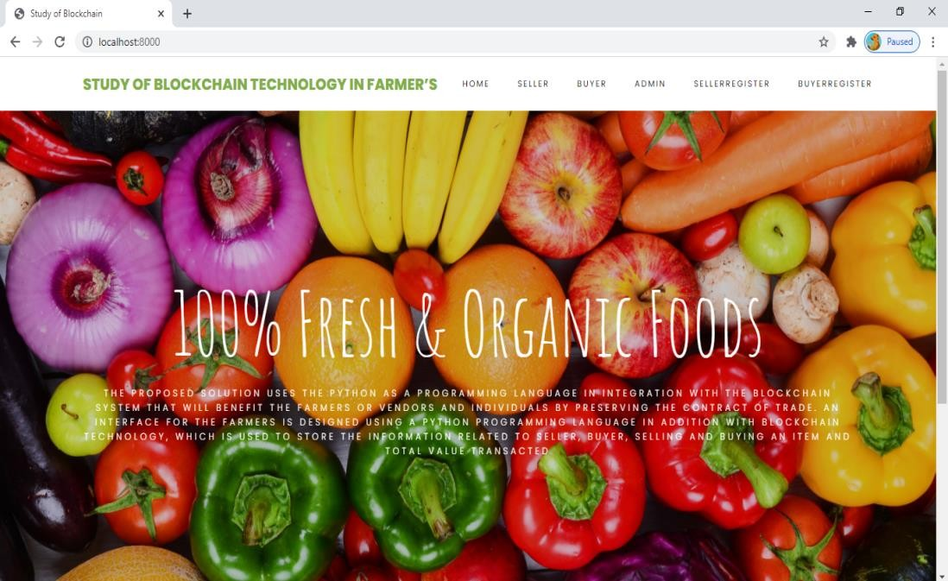

Fig No.4.1 : Home Page

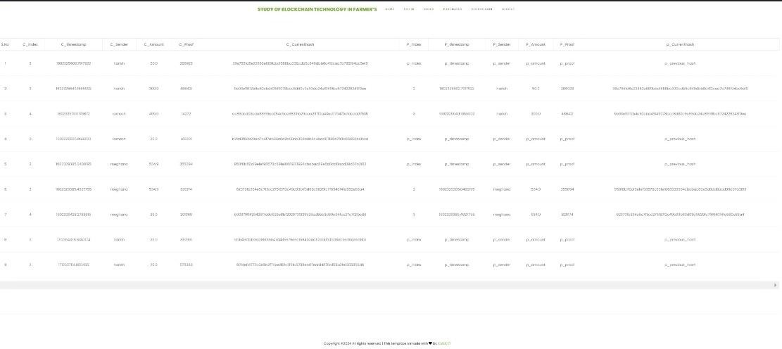

Fig No.4.2 : Admin Side Data

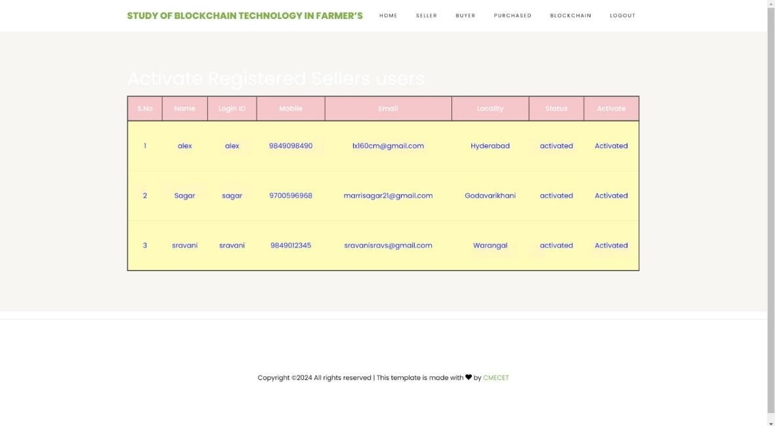

Fig No.4.3 : ViewSellers Registered Users

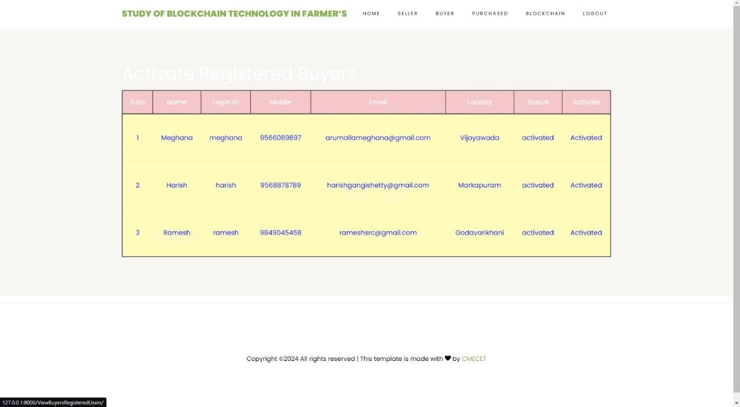

Fig No.4.4 : ViewBuyers Registered Users

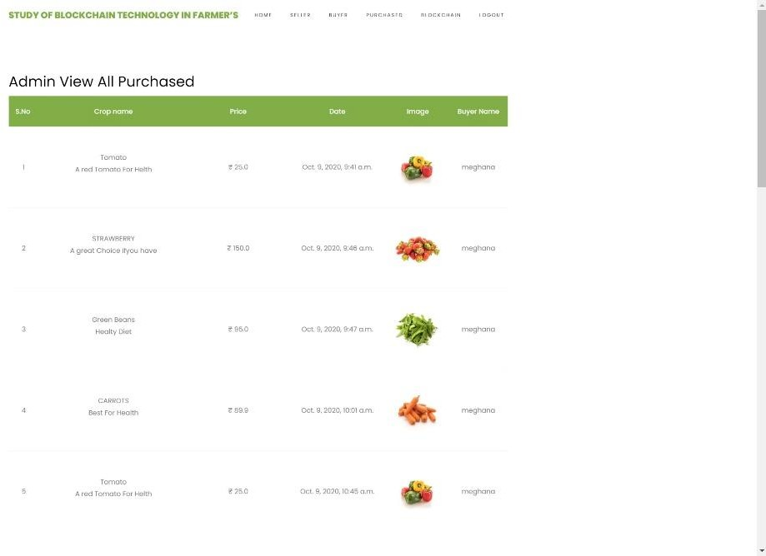

Fig No.4.5 :Admin View All Purchased

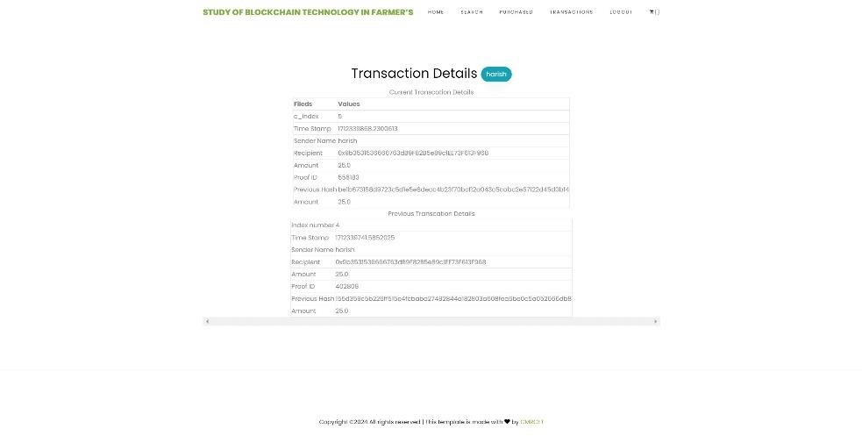

Fig No.4.6 Transaction Details

# CHAPTER 5

## CONCLUSION

###### CHAPTER 5 CONCLUSION

Blockchain technology holds immense potential to revolutionize the agricultural sector by providing secure data management for farmers, ensuring seed quality, monitoring soil moisture levels, tracking crop yield data, and determining demand and sale prices of crops. The proposed blockchain-based portal aims to address the challenges related to crop pricing and security for farmers. Through this portal, farmers can register and sell their crops, with each transaction securely recorded on the blockchain. Notably, the system facilitates wallet-to-wallet transactions, allowing seamless and secure transfer of funds between buyers and sellers.

By leveraging blockchain technology, the proposed portal enhances transparency and trust in agricultural transactions. Farmers can receive fair prices for their crops while reducing operational costs associated with traditional selling methods. Moreover, the immutable nature of blockchain ensures that crop details, pricing commitments, and transaction quantities are securely recorded, providing farmers with a reliable platform to negotiate and finalize sales. Wallet-to-wallet transactions further streamline the process, offering a secure means for buyers to transfer funds directly to farmers, enhancing financial efficiency and reducing intermediary involvement.

In conclusion, the implementation of blockchain technology in agriculture through the proposed portal offers a promising solution to the challenges faced by farmers in securing fair prices for their crops. By enabling secure transactions and transparent pricing mechanisms, the portal empowers farmers to achieve better returns on their agricultural produce while minimizing transaction costs. Additionally, the inclusion of wallet-to-wallet transactions adds another layer of security and efficiency to the agricultural supply chain, fostering trust and sustainability in the industry.

## REFERENCES

###### REFERENCES

[1]. Arpit Narechania “KisanVikas – Android Based ICT Solution in IndianAgriculture to Assist Farmers”. Proceeding of the 7th International Conference on Information andCommunication Technologies in Agriculture, Food and Environment (HAICTA 2015), Kavala, Greece, 17-20 September, 2015.

[2]. ICT in Agriculture (2020). National Round Table Conference. [Online] Available from: <https://www.icfa.org.in/assets/doc/reports/ICT_in_Agriculture.pdf>

[3]. Krishi-Bharati: An Interface for Indian Farmer," presented at the 2014 IEEEStudents' Technology Symposium in Kharagpur, India, authored by Soumalya Ghosh, A. B. Garg, Sayan Sarcar, P.S.V.S Sridhar, Ojasvi Maleyvar, and Raveesh Kapoor.

[4]. https://www.google.com/url?sa=t&source=web&rct=j&opi=89978449&url=https://tu rcomat.org/index.php/turkbilmat/article/download/13928/9975/24762%23:~:text%3DFor% 2520this%252C%2520a%2520portal%2520is,and%2520quantity%2520of%2520crop%252 0purchased.&ved=2ahUKEwjJ8tSOiKmFAxXA7DgGHT20BFIQFnoECA8QBg&usg=AO vVaw0ocdkqZpty6LWZpn4Stema

[5]. https://www.google.com/url?sa=t&source=web&rct=j&opi=89978449&url=https://w ww.irjet.net/archives/V8/i12/IRJET- V8I12150.pdf&ved=2ahUKEwjI8NqOiamFAxWczjgGHapnA6YQFnoECA8QAQ&sqi=2 &usg=AOvVaw0Pnb9LTbIfwzwnwtx0kvCz

[6]. https:/[/www.irjet.net/ar](http://www.irjet.net/archives/V8/i12/IRJET-V8I12150.pdf)c[hives/V8/i12/IRJET-V8I12150.pdf](http://www.irjet.net/archives/V8/i12/IRJET-V8I12150.pdf)

[7]. <https://www.jetir.org/papers/JETIR2205331.pdf>

[8]. <https://ieeexplore.ieee.org/document/9182969>

[9]. <https://www.investopedia.com/terms/b/blockchain.asp>

[10]. <https://www.blockchain.com/learning-portal/wallet-faq>

[11]. <https://jis-eurasipjournals.springeropen.com/articles/10.1186/s13635-019-0085-3>

[12]. https:/[/www.scienc](http://www.sciencedirect.com/science/article/pii/S2666764923000280)e[direct.com/science/article/pii/S2666764923000280](http://www.sciencedirect.com/science/article/pii/S2666764923000280)

###### GITHUB LINK

* https://github.com/Dattasai02/Major_Project



# 1st International Conference

**on**

**Recent Trends in Engineering & Management Science**

# (ICRTEM-2024)

**11th &12th March 2024, Hybrid Mode**

**PROCEEDINGS BOOK**



**Organized by**

**SAI SPURTHI INSTITUTE OF TECHNOLOGY**

**SATHUPALLY**

**In association with**



**NEWZEN INFOTECH, HYDERABAD**

[**www.icrtem.com**](http://www.icrtem.com/) **|** [**www. saispurthi.ac.in**](http://www.saispurthi.ac.in/)

## ISBN No: 978-81-967875-5-4

Proceedings of **International Conference on Recent Trends in Engineering and Management Science**

**(ICRTEM-2024), March 11th & 12th 2024**

**Paper ID: ICRTEM24_134**

**A STUDY OF BLOCKCHAIN BASED PORTAL FOR FARMERS: EXPLORING A BLOCKCHAIN-BASED PORTAL FOR AGRICULTURAL ADVANCEMENT**

**#1 V. Datta Sai , *UG Student***

**#2 K. Sreehaas , *UG Student***

**#3 T.Himesh Baradwaj , *UG Student*#4 K.Jyothi ,**

***Assistant Professor* Department of CSE**

CMR COLLEGE OF ENGINEERING & TECHNOLOGY, HYDERABAD.

**ABSTRACT-**Blockchain is like a super-secure digital ledger that records transactions across multiple computers in a way that makes it nearly impossible to alter or tamper with the data once it's been added. Think of it as a chain of blocks, where each block contains a batch of transactions, and these blocks are linked together in a chronological and encrypted manner, forming a continuous chain. This decentralized and transparent system ensures trust and reliability without the need for intermediaries like banks or governments. Blockchain technology functions as an exceptionally secure digital ledger, recording transactions across numerous computers in a manner that greatly minimizes the risk of alteration or tampering. Conceptually, it operates akin to a series of blocks, with each block encapsulating a group of transactions.These blocks are then linked together sequentially in a manner that is both chronological and encrypted, forming an unbroken chain of data. This decentralized and transparent system fosters trust and reliability, bypassing the need for intermediaries such as banks or governments. This document underscores the integration of blockchain technology within a farmer's platform, facilitating the secure storage of transactional data pertaining to crop sales and purchases. The integration of blockchain technology within a farmer's platform highlights its utility in securely storing transactional data related to crop sales and purchases. By leveraging blockchain, the platform ensures the integrity and authenticity of these transactions, enhancing transparency and efficiency in agricultural trade.

***Keywords:*** *Blockchain, Digital Ledger, Transactions, Multiple computers, Alteration, Tampering, Chain of blocks, Chronological, Encrypted, Decentralized, Transparent, Trust, Reliability, Famer’s platform, Crop Sales.*

E-Proceedings Book Available: [www.icrtem.com](http://www.icrtem.com/)

**A STUDY OF BLOCKCHAIN BASED PORTAL FOR FARMERS:**

EXPLORING A BLOCKCHAIN-BASED PORTAL FOR AGRICULTURAL ADVANCEMENT

#1 V. Datta Sai , #2 K. Sreehaas , #3 T.Himesh Baradwaj , #4 K.Jyothi,

1,2,3 UG Student, Department of CSE, CMR College of Engineering & Technology, Hyderabad, Telangana

4 Assistant Professor, Department of CSE, CMR College of Engineering & Technology, Hyderabad, Telangana

***Corresponding Author: V. Datta Sai ,*** [***dattasaivadla02@gmail.com***](mailto:dattasaivadla02@gmail.com)

***Abstract*— Blockchain is like a super-secure digital ledger that records transactions across multiple computers in a way that makes it nearly impossible to alter or tamper with the data once it's been added. Think of it as a chain of blocks, where each block contains a batch of transactions, and these blocks are linked together in a chronological and encrypted manner, forming a continuous chain. This decentralized and transparent system ensures trust and reliability without the need for intermediaries like banks or governments.Blockchain technology functions as an exceptionally secure digital ledger, recording transactions across numerous computers in a manner that greatly minimizes the risk of alteration or tampering. Conceptually, it operates akin to a series of blocks, with each block encapsulating a group of transactions. These blocks are then linked together sequentially in a manner that is both chronological and encrypted, forming an unbroken chain of data. This decentralized and transparent system fosters trust and reliability, bypassing the need for intermediaries such as banks or governments.This document underscores the integration of blockchain technology within a farmer's platform, facilitating the secure storage of transactional data pertaining to crop sales and purchases.The integration of blockchain technology within a farmer's platform highlights its utility in securely storing transactional data related to crop sales and purchases. By leveraging blockchain, the platform ensures the integrity and authenticity of these transactions, enhancing transparency and efficiency in agricultural trade.**

***Keywords— Blockchain, Digital Ledger, Transcations, Multiple computers, Alteration, Tampering, Chain of blocks, Chronological, Encrypted, Decentralized, Transparent, Trust, Reliability, Famer’s platform, Crop Sales.***

1. INTRODUCTION

In the ever-evolving landscape of agriculture, farmers face a myriad of challenges, with one of the most persistent being the issue of brokerage. Across the globe, farmers grapple with intermediaries who often wield considerable power over the distribution and pricing of their produce. These middlemen, while serving as a vital link between farmers and consumers, frequently impose hefty fees and commissions, diminishing the profits that rightfully belong to the farmers themselves. This reliance on intermediaries not only undermines the economic viability of farming but also exacerbates disparities in wealth distribution within rural communities. [6]

Enter blockchain technology—a groundbreaking innovation poised to revolutionize various sectors, including agriculture. At its core, blockchain offers a decentralized and transparent system for recording and verifying transactions. By leveraging cryptographic principles[1], blockchain ensures the integrity and security of data, making it nearly impossible for unauthorized parties to alter or manipulate records. This inherent trustworthiness of blockchain holds immense promise for addressing the challenges faced by farmers worldwide.

The application of blockchain extends far beyond the realms of finance and technology, permeating diverse sectors such as supply chain management, logistics, and even governance. In supply chain management, blockchain enables

end-to-end traceability, allowing consumers to track the journey of agricultural products from farm to fork. This transparency not only fosters consumer trust but also empowers farmers by providing them with greater visibility into the value chain.

In the logistics sector, blockchain facilitates seamless coordination among stakeholders, streamlining processes such as transportation and warehousing. By reducing inefficiencies and minimizing paperwork, blockchain enhances the overall efficiency of agricultural operations, ultimately benefiting farmers.

Moreover, blockchain holds immense potential in transforming governance systems, particularly in regions plagued by corruption and bureaucracy. Through the immutable nature of blockchain records, governments can enhance transparency and accountability in agricultural policies and resource allocation, ensuring that farmers receive the support and resources they require to thrive.

As we delve deeper into the intersection of farmers and blockchain technology, it becomes evident that the adoption of blockchain holds transformative implications for the agricultural sector. By mitigating the challenges posed by brokerage and fostering transparency and efficiency across various sectors, blockchain emerges as a powerful tool for empowering farmers and catalyzing sustainable agricultural development.

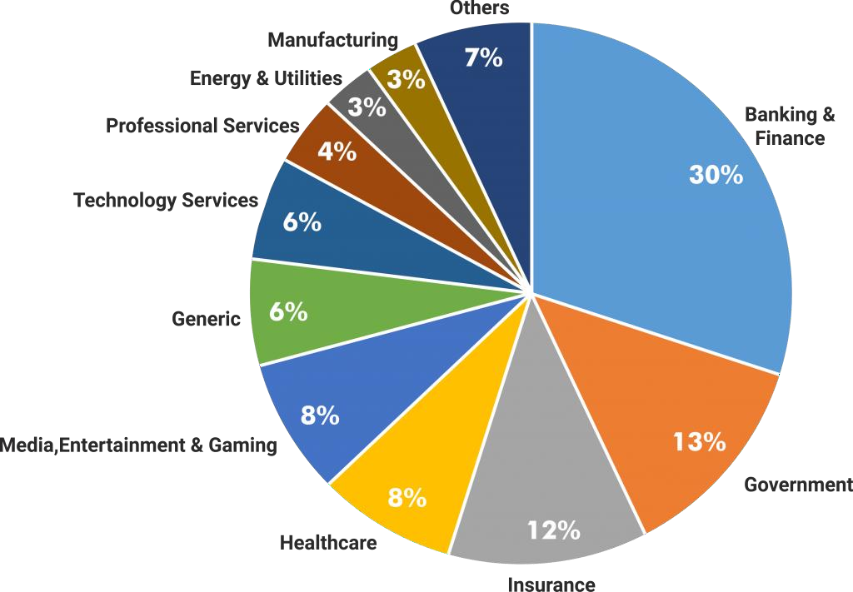

1. RELATED WORK

Fig. 1 Sectors Using Blockchain [2]

**D. Decentralized Agricultural Tracing Systems:**

In the quest for innovation and efficiency, modern projects frequently rely on existing solutions as fundamental building blocks for development. This approach not only recognizes the expertise and advancements of those who came before us but also nurtures a collaborative ecosystem where ideas can evolve and confront new challenges. In our project, we wholeheartedly embrace this ethos, conscientiously integrating elements from existing solutions to enrich our endeavor. These existing solutions serve as guiding lights, offering insights and frameworks that shape the direction of our project.[4]

1. **ICT-Based Solutions for Farmers:** Several studies have explored the development of ICT solutions to provide farmers with valuable information and updates related to agricultural techniques, products, weather forecasts, and news. These solutions typically offer interfaces that allow farmers to interact via text or speech input, facilitating access to relevant information.
2. **Mobile Applications for Agricultural Updates:**

Researchers have proposed mobile applications designed to cater to the needs of farmers by providing instant updates on agricultural matters. While these applications offer valuable services, some limitations, such as language barriers (e.g., availability only in English), hinder their effectiveness in reaching a wider audience of farmers.[3]

1. **Blockchain in Agriculture Supply Chain Management:**

The incorporation of blockchain technology into agriculture has shown promise, particularly in improving the efficiency of supply chain management. By leveraging blockchain, the need for extensive data verification is reduced, leading to enhanced accuracy and reliability in supply chain operations. However, it's noted that current implementations primarily benefit producers by ensuring data accuracy for the supply chain.

Researchers have explored the use of blockchain technology to develop decentralized agricultural tracing systems. These systems aim to collectively maintain and provide trust and reliability in supply chain management by safeguarding immutable data related to production and supply. While beneficial for producers in terms of data integrity, the broader implications and adoption challenges of such systems remain subjects for further exploration.[5]

Overall, the analysis underscores the ongoing efforts to leverage technology, including ICT and blockchain, to address various challenges faced by farmers and enhance the efficiency and reliability of agricultural processes, particularly in supply chain management and information dissemination.

1. PROPOSED METHODS AND ITS ARCHITECTURE

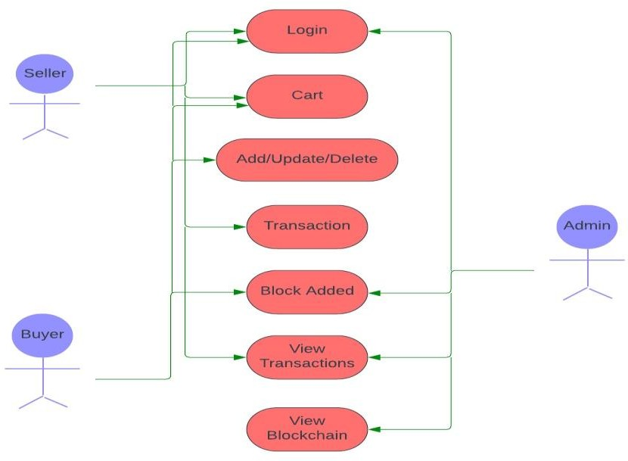

Fig. Use Case Diagram

1. ***Sellers***

To start their journey, sellers must first register by providing a valid email address and mobile number for communication purposes. After registration, it's the admin's responsibility to activate these seller accounts. Once activated, sellers gain access to the system and can log in. They are then empowered to add new items, update existing listings, and adjust item prices. This autonomy allows them to expand their market reach and diminishes the reliance on intermediaries during the selling process.

1. ***Buyers***

Buyers follow a similar registration process, providing valid email and mobile information for future communication. Admin approval is required for these buyer accounts to become active, granting users access to the system. Buyers can then browse and purchase products that meet their needs. They have the freedom to add products to their shopping cart and remove items as necessary. Once they've finalized their selections and verified their cart, users can proceed to the checkout process.

1. ***Admin***

Administrators access the system using their own credentials. Their role involves activating both seller and buyer accounts, ensuring that only activated users can log in. Additionally, the admin user has oversight over all transactions conducted by buyer users. The admin interface provides visibility into all blockchain transactions, displaying details of previous blocks and hash values for comprehensive monitoring.

SCHEMATIC FLOW DIAGRAM OF PROPOSED WORK

The schematic flow diagram illustrates the functionalities of the proposed portal. Users first register and log in as either a buyer or a seller. Depending on their role, the portal displays the respective home page. Buyers can browse, search, view, add items to their cart, and proceed to purchase. Sellers, on the other hand, can manage item quantities by adding, deleting, or updating listings, facilitating sales. Transactions are recorded on the blockchain when an item is purchased or sold. Upon completion of activities, users can log off through the interface to end their session.

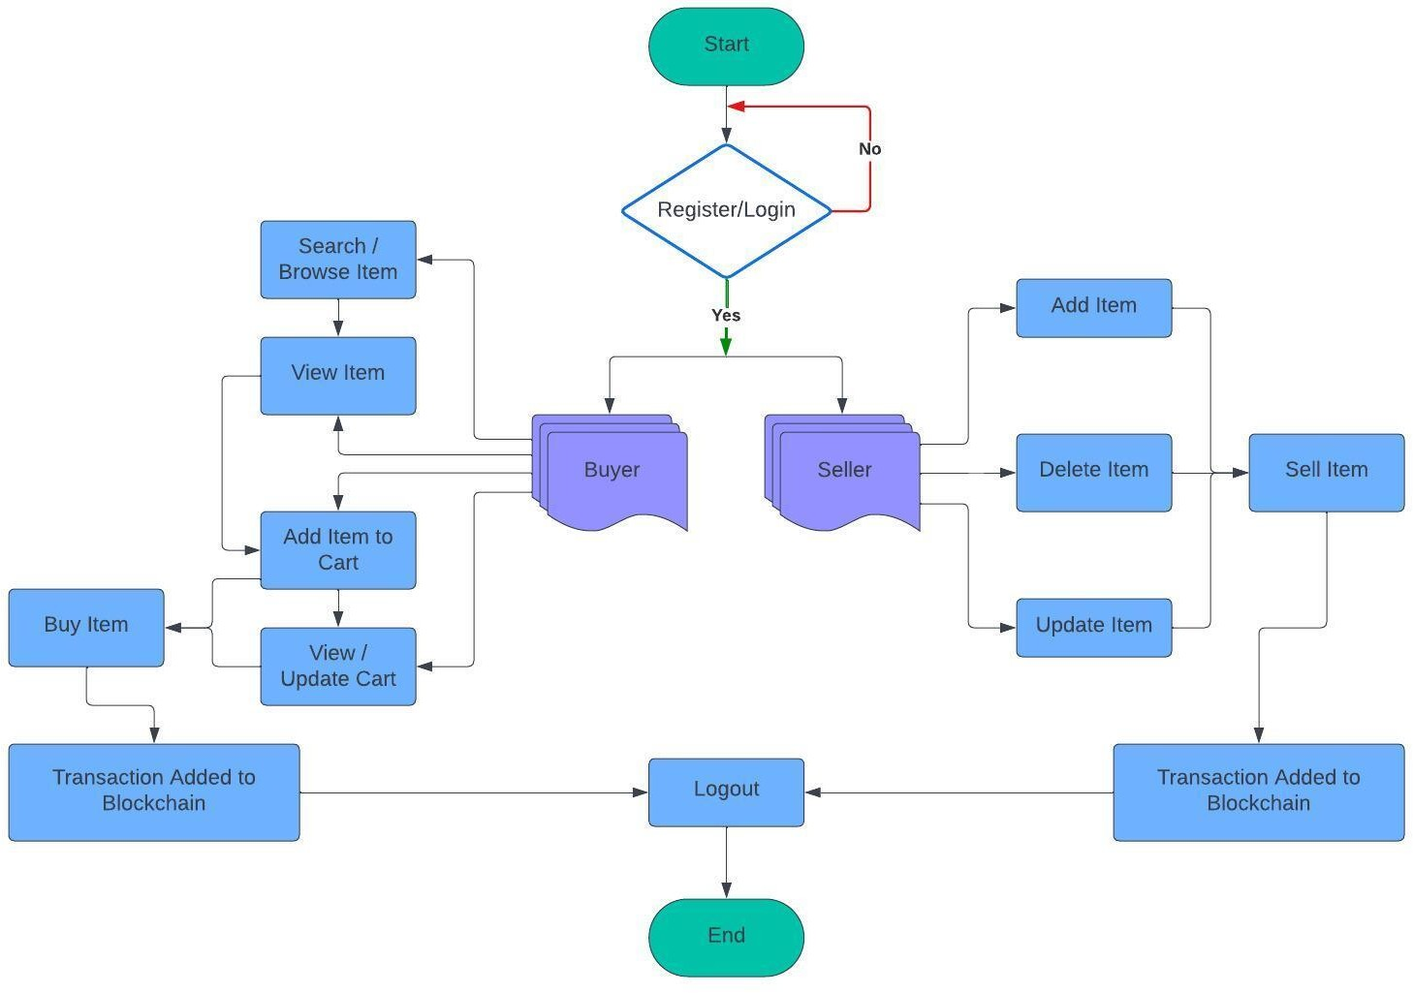

Fig. Schematic Flow Diagram

1. CONCLUSION

Blockchain technology holds immense potential to revolutionize the agricultural sector by securely maintaining farmers' data and ensuring the integrity of transactions and crop sale prices. In this project, a blockchain-based portal addresses the critical issue of demand and fair pricing for crops, thereby enhancing crop security for farmers. Through the portal, farmers can register and sell their crops, with each transaction recorded immutably on the blockchain. This transaction captures crucial details such as crop specifications, committed purchase price, and quantity purchased.

The immutable nature of blockchain technology guarantees that farmers receive a fair and legitimate price for their crops, while also reducing the operational costs associated with traditional selling and buying methods. By leveraging blockchain, this project not only empowers farmers with greater control over their agricultural transactions but also fosters transparency and efficiency throughout the agricultural supply chain. Moreover, the implementation of blockchain technology in agriculture has the potential to streamline processes, mitigate risks associated with fraud and counterfeiting, and facilitate access to financial services for farmers in remote areas.

Furthermore, the transparency provided by blockchain can strengthen trust between stakeholders in the agricultural value chain, including farmers, buyers, distributors, and consumers. This increased trust can lead to more sustainable and ethical practices, as well as greater accountability throughout the industry. Overall, the integration of blockchain technology in agriculture has the capacity to drive significant improvements in productivity, profitability, and sustainability, ultimately benefiting farmers and consumers alike.

REFERENCES

1. Hileman, Garrick, and Michel Rauchs. "2017 Global Blockchain Benchmarking Study." Available at SSRN 3040224 (2017).
2. [https://www.esds.co.in/blog/blockchain-technology-a-](https://www.esds.co.in/blog/blockchain-technology-a-silver-lining-to-bfsi-industry/) [silver-lining-to-bfsi-industry/](https://www.esds.co.in/blog/blockchain-technology-a-silver-lining-to-bfsi-industry/)
3. Yadav,Vinay Surendra, and A. R. Singh. “A Systematic Literature Review of Blockchain Technology in Agriculture.”
4. Ghosh, Soumalya,A. B. Garg, Sayan Sarcar, PSV S. Sridhar, Ojasvi Maleyvar, and Raveesh Kapoor. "Krishi- Bharati: An Interface for Indian Farmers”. In Proceedings of the 2014 IEEE Students' Technology Symposium, pp. 259-

263. IEEE, 2014.

1. Zhu, Xingxiong, and Dong Wang. "Research on Blockchain Application for E-Commerce, Finance and Energy." In IOP Conference Series: Earth and Environmental Science, vol. 252, no. 4, p. 042126. IOP Publishing, 2019.
2. https[://www.](http://www.researchgate.net/figure/Problems-faced-by-)r[esear](http://www.researchgate.net/figure/Problems-faced-by-)ch[gate.net/figure/Problems-faced-by-](http://www.researchgate.net/figure/Problems-faced-by-) the-farmers-in-selling-their-produce_fig2_262525855

